How Spring Boot Builds Your Application Using Configuration ??
(application.properties vs application.yml + pom.xml + starters + auto-configuration)

Why Configuration Exists ?
In enterprise systems, code is not the only thing that changes.
Environment, ports, databases, credentials, logging levels, feature flags change much more frequently than Java code.
Spring Boot separates:
- What the app does → Java code
- How the app runs → Configuration
That is why configuration is externalized into:
- pom.xml
- application.properties
- application.yml
- environment variables
- config folders
Spring Boot then converts all of this into a runtime Environment that controls:
- which beans exist
- which server runs
- which database connects
- which auto-configs activate

What is application.properties?
application.properties is the control panel of your application.
It lives in:
src/main/resources/application.properties
It is loaded during Spring Boot startup — before any beans are created.

Example:
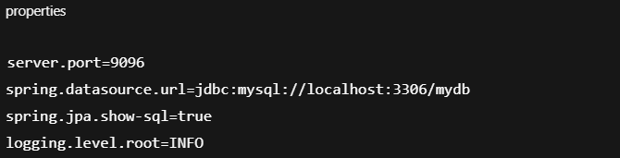This overrides Spring Boot defaults:
Default | Your override
8080 | 9096
H2 | MySQL
minimal logs | detailed logs
Spring Boot reads this file and builds a giant map called Environment.

Custom Properties
You can define your own keys:

Read them:
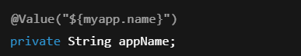
Why we added @Value annotation?
So values change without recompiling Java.

Why @Value Exists
Without @Value, Java code is hard-wired.
With @Value, configuration becomes externalized.
This allows:
- different DBs in prod vs dev
- different ports
- different credentials
- different feature toggles

Custom Properties File
Spring Boot only auto-loads:
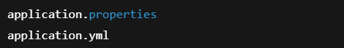
Not:
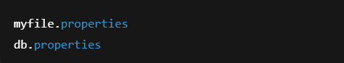
To load custom properties files:
Use @PropertySource Annotation with file name/path
If file is in:
Use:
Add below @SpringBootApplication in Starter app Spring adds it into Environment.
Where Spring Boot Searches for application.properties ?
Spring Boot searches in this order:
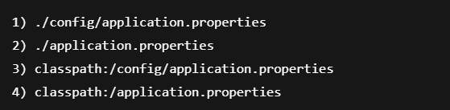
So:
is valid
But:
is ignored unless you use @PropertySource.

External Config Folder
You can place:

next to your JAR.
Spring Boot auto-detects it.
This is how DevOps configures prod without touching code.

Why file must be named application.properties ?
Spring Boot auto-loader looks for only one name:
application
Anything else is ignored unless explicitly imported.

YAML
YAML = structured configuration.
Example:
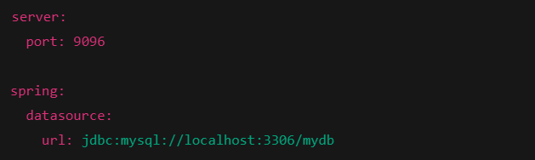Same as:
YAML is preferred for complex configs.

properties vs yaml
Properties | YAML
Flat | Hierarchical
Hard to read | Clean
Good for small | Best for large

Startup & Configuration Flow
From Spring Initializr:
You get:
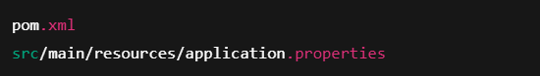
Why?
Because Spring Boot needs configuration before code runs.
Startup:
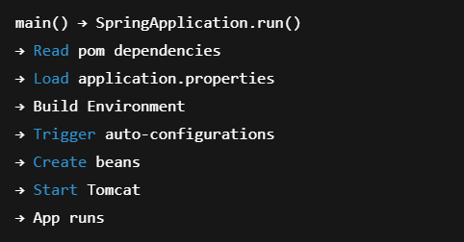
Loaded once per startup.

How pom.xml, starters & properties work together ?
pom.xml:
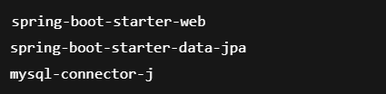

Spring Boot sees:
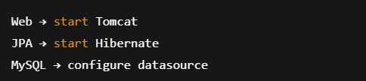
application.properties controls:
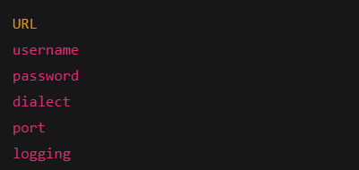
Environment → Auto-configuration → Beans → Server

Good vs Broken Example
Working:
Broken:
Auto-config fails because key is wrong.

Hidden Traps
- Misspelled properties silently fail
- Multiple config files override each other
- YAML indentation errors break parsing
- External configs override classpath
- Profiles (application-dev.properties) change everything
Interview Perspective
Interviewers test:
- Do you know who controls Spring Boot
- Do you understand why config drives beans
- Can you debug startup failures

Interview Questions
- When is application.properties loaded?
→ During bootstrap before beans.
- Why must it be named application.properties?
→ Spring Boot auto-loader.
- Where is it searched?
→ classpath, config, external folder.
- How does DB get configured?
→ pom + properties → auto-config.
- What is Environment?
→ Key-value map of all configuration.
- YAML vs properties?
→ Same values, different format.
- What if property is missing?
→ Default used or bean fails.
- Can it live outside jar?
→ Yes, in config folder.
- What does starter do?
→ Pulls correct dependency set.
- What drives auto-configuration?
→ Environment + classpath.
One-Page Mental Model
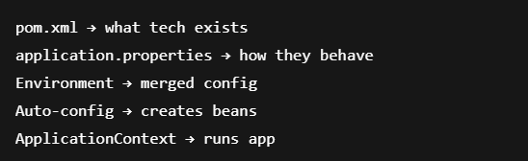

Enterprise Relevance
This is how:
- prod differs from dev
- cloud overrides ports
- Kubernetes injects secrets
- CI/CD deploys without rebuilds

Final Summary — Story
You generate a Spring Boot project.
It gives you pom.xml and application.properties.
You add:
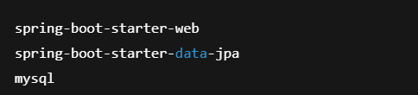
You write:
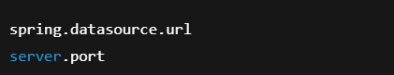

When the app starts:
Spring Boot:
→ Reads pom
→ Loads application.properties
→ Builds Environment
→ Activates auto-config
→ Creates Tomcat, DB, JPA, Controllers
→ Runs your app
You never wired anything manually — configuration drove everything.

Definitions
Term | Meaning
pom.xml | Declares what technologies your app uses
Starter | A curated bundle of dependencies
application.properties | Flat key-value configuration
application.yml | Structured configuration format
Environment | Spring’s in-memory map of all config values
Auto-configuration | Spring Boot creating beans based on environment
Bean | A Java object managed by Spring
Container (ApplicationContext) | Holds and wires all beans

XML → eXtensible Markup Language
YAML → YAML Ain’t Markup Language

